Assignment7

1. Scroll to the top of the page with jQuery

Output:



Code Snippet

<!DOCTYPEhtml>

<html>

<head>

<script src="https://code.jquery.com/jquery-3.3.1.js"></script>

<meta charset="utf-8">

<title>Jquery 1</title>

<script>

$(document).ready(function () {

$("a[href='#top']").click(function () {

$("html, body").animate({ scrollTop: 0 }, "slow");

return false;

});

});

</script>

</head>

<body>

<p>jquery</p>

<p>jquery</p>

<p>jquery</p>

<p>jquery</p>

<p>jquery</p>

<p>jquery</p>

<p>jquery</p>

<p>jquery</p>

<p>jquery</p>

<p>jquery</p>

<p>jquery</p>

<p>jquery</p>

<p>jquery</p>

<p>jquery</p>

<p>jquery</p>

<p>jquery</p>

<p>jquery</p>

<p>jquery</p>

<p>jquery</p>

<p>jquery</p>

<p>jquery</p>

<p>jquery</p>

<p>jquery</p>

<p>jquery</p>

<p>jquery</p>

<p>jquery</p>

<p>jquery</p>

<p>jquery</p>

<p>jquery</p>

<p>jquery</p>

<p>jquery</p>

<p>jquery</p>

<p>jquery</p>

<p>jquery</p>

<p>jquery</p>

<p>jquery</p>

<p>jquery</p>

<p>jquery</p>

<p>jquery</p>

<p>jquery</p>

<p>jquery</p>

<p>jquery</p>

<p>jquery</p>

<p>jquery</p>

<p>jquery</p>

<p>jquery</p>

<p>jquery</p>

<p>jquery</p>

<p>jquery</p>

<p>jquery</p>

<p>jquery</p>

<p>jquery</p>

<p>jquery</p>

<p>jquery</p>

<p>jquery</p>

<p>jquery</p>

<p>jquery</p>

<p>jquery</p>

<p>jquery</p>

<p>jquery</p>

<p>jquery</p>

<p>jquery</p>

<p>jquery</p>

<p>jquery</p>

<p>jquery</p>

<p>jquery</p>

<p>jquery</p>

<p>jquery</p>

<p>jquery</p>

<p>jquery</p>

<p>jquery</p>

<p>jquery</p>

<p>jquery</p>

<p>jquery</p>

<p>jquery</p>

<p>jquery</p>

<p>jquery</p>

<p>jquery</p>

<p>jquery</p>

<p>jquery</p>

<p>jquery</p>

<p>jquery</p>

<p>jquery</p>

<p>jquery</p>

<p>jquery</p>

<p>jquery</p>

<p>jquery</p>

<p>jquery</p>

<p>jquery</p>

<p>jquery</p>

<p>jquery</p>

<p>jquery</p>

<p>jquery</p>

<p>jquery</p>

<p>jquery</p>

<p>jquery</p>

<p>jquery</p>

<p>jquery</p>

<p>jquery</p>

<p>jquery</p>

<p>jquery</p>

<p>jquery</p>

<p>jquery</p>

<p>jquery</p>

<p>jquery</p>

<p>jquery</p>

<p>jquery</p>

<p>jquery</p>

<p>jquery</p>

<p>jquery</p>

<p>jquery</p>

<p>jquery</p>

<p>jquery</p>

<p>jquery</p>

<p>jquery</p>

<p>jquery</p>

<p>jquery</p>

<p>jquery</p>

<p>jquery</p>

<p>jquery</p>

<p>jquery</p>

<p>jquery</p>

<p>jquery</p>

<p>jquery</p>

<p>jquery</p>

<p>jquery</p>

<a href='#top'>GoTop</a>

</body>

</html>

1. How to detect a textbox's content has changed using jQuery?

Output:

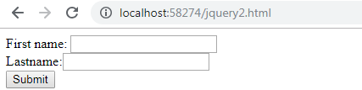

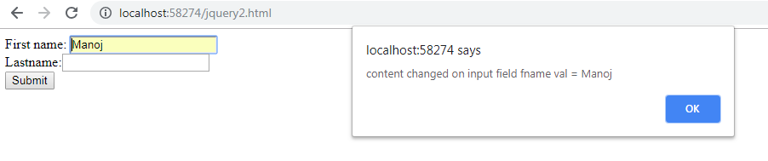

Code Snippet

<!DOCTYPE html>

<html xmlns="http://www.w3.org/1999/xhtml">

<head>

<script src="https://code.jquery.com/jquery-3.3.1.js"></script>

<meta charset="utf-8">

<meta name="viewport" content="width=device-width">

<title>Jquery -detect text box</title>

<script>

$(document).ready(function () {

jQuery('#name1').on('input propertychange paste', function () {

alert('content changed on input field ' + this.name + ' val = ' + $(this).val());

});

jQuery('#name2').on('input propertychange paste', function () {

alert('content changed on input field ' + this.name + ' val = ' + $(this).val());

});

});

</script>

</head>

<body>

<form action="demo_form.asp">

First name: <input type="text" id="name1" name="fname">

<br>

Lastname:<input type="text" id="name2" name="lname">

<br>

<input type="submit" value="Submit">

</form>

</body>

</html>

1. Change button text using jQuery

Output:

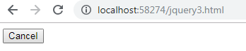



Code Snippet

<!DOCTYPE html>

<html>

<head>

<script src="https://code.jquery.com/jquery-git.js"></script>

<meta charset="utf-8">

<meta name="viewport" content="width=device-width">

<title>Jquery 3 - ChangebuttontextusingjQuery.</title>

<script>

$(document).ready(function () {

$("#button1").click(function () {

$("#button1").prop('value', 'Save');

});

});

</script>

</head>

<body>

<input type='button' value='Cancel' id='button1'>

</body>

</html>

4. Add 3 new options to a drop-down list using jQuery

Output:

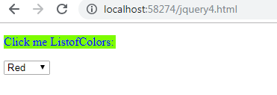

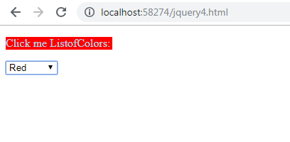

Code Snippet

<!DOCTYPE html>

<html>

<head>

<script src="https://code.jquery.com/jquery-git.js"></script>

<meta charset="utf-8">

<meta name="viewport" content="width=device-width">

<title>Jquery 4 - Add options to a drop-down list using jQuery.</title>

<script>

$(document).ready(function () {

$("#ListofColors").click(function () {

$(this).off("click");

$("#myColors").append('<option value="Brown">Brown</option>');

$("#myColors").append('<option value="Blue">Blue</option>');

$("#myColors").append('<option value="SkyBlue">SkyBlue</option>');

$(this).removeClass('AddMe').addClass('done');

});

});

</script>

<style>

.AddMe {

color: blue;

background-color: lawngreen;

width: 150px;

}

.done {

color: lightblue;

background-color: red;

width: 150px;

}

</style>

</head>

<body>

<p id="ListofColors" class="AddMe">Click me ListofColors:</p> <select id='myColors'>

<option value="Red">

Red

</option>

<option value="Green">

Green

</option>

<option value="White">

White

</option>

<option value="Black">

Black

</option>

</select>

</body>

</html>

1. Set background-image using jQuery CSS property

Output:



Code Snippet

<!DOCTYPE html>

<html>

<head>

<script src="https://code.jquery.com/jquery-git.js"></script>

<meta charset="utf-8">

<meta name="viewport" content="width=device-width">

<title>Jquery 5- Set background-image using jQuery CSS property.</title>

<script>

$(document).ready(function () {

$(".body").css("background-image", "url('/image/background.jpeg')");

});

</script>

</head>

<body class="body">

</body>

</html>